
BALDIVIS SECONDARY COLLEGE
YEAR 11 MATHEMATICS SPECIALIST 2020
TEST 1A
TOPICS: Combinatorics (1.1.1 – 1.1.9) and Proof (1.3.1 – 1.3.5)

INSTRUCTIONS:
No Calculator
Notes not allowed
Full working must be shown for all questions (or parts) worth more than 2 marks.
Marks will be deducted for rounding and unit errors.
Name: Time: 55 minutes Total / 57

Question 1 [ 1, 1, 1 = 3 marks ]
Simplify, evaluating where possible, the following:

- 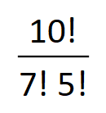 b) 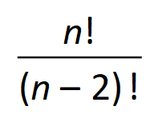 c) 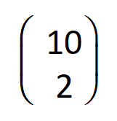

Question 2 [ 1, 1, 1 = 3 marks ]
For the statement “If the weather is nice, then I will take a walk” write its:
- Inverse

- Contrapositive

- Converse

Question 3 [ 2, 2, 3, 3 = 10 marks]
The digits 0, 1, 2, 3, 4, 5, 6 are to be arranged without repetition to form a 4 digit number which cannot start with 0.
- How many different arrangements are possible

- How many arrangements are greater than 3000

- How many arrangements are even

- How many arrangement are greater than 3000 or even

Question 4 [ 1, 1, 2, 2 = 6 marks ]
A box contains crayons of different colours. There are 5 blue, 3 green, and 2 black. How many crayons must be drawn to ensure that
- There is 1 blue crayon

- There are 2 crayons of each colour

- There is a blue or a black crayon

- There are more blue than black crayons

Question 5 [ 2, 2, 2 = 6 marks ]
A committee of 10 is to be chosen from 7 farmers, 8 grocers and 5 distributers.
Determine the number of ways of selecting the committee if it has to contain:

[ YOU MAY LEAVE YOUR ANSWERS AS FACTORIALS OR IN THE FORM 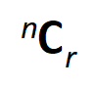 ]
- Exactly 3 farmers and 4 grocers

- Exactly 2 distributers

- More farmers and grocers (combined) than distributers

Question 6 [ 6 marks ]

How many numbers less than 2000 (inclusive) are divisible by 3, 8, or 10

Question 7 [ 2, 2, 2, 3 = 9 marks ]
How many ‘words’ can be made from the letters of the word CONTINUOUS, if

[ YOU MAY LEAVE YOUR ANSWERS AS FACTORIALS OR IN THE FORM  ]
- All ten letters are to be used

- All ten letters are to be used and the letters C and S must be next to each other

- Five letters are to be used and the word cannot contain more than one of each letter
(i.e. no letter is to be repeated)

- Five of the ten letters are to be used and the ‘word’ must contain exactly two vowels

Question 8 [ 4 marks ]
Decide if the following statement is true or false:
“ Given any 100 consecutive whole numbers, one can choose any 15 numbers so that at least two of the chosen numbers have a difference between them that is always divisible by 7 “

Justify your answer.

Question 9 [ 4 marks ]
Show, using proof by contradiction, that if 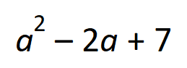 is even, then a is odd , a is an integer

Question 10 [ 6 marks ]

For each of the following statements, state if it is true or fase.
If it is false, provide a counter example
- If the total exterior angle of a polygon is equal to 360°, then its total interior angle is also
equal to 360°

- 

 